Project Report

Name: M. Abdullah Naeem Afzal SAP: 44722

**Example-1:**

E -> T E'

E' -> + T E' | ε

T -> F T'

T' -> * F T' | ε

F -> id | ( E )

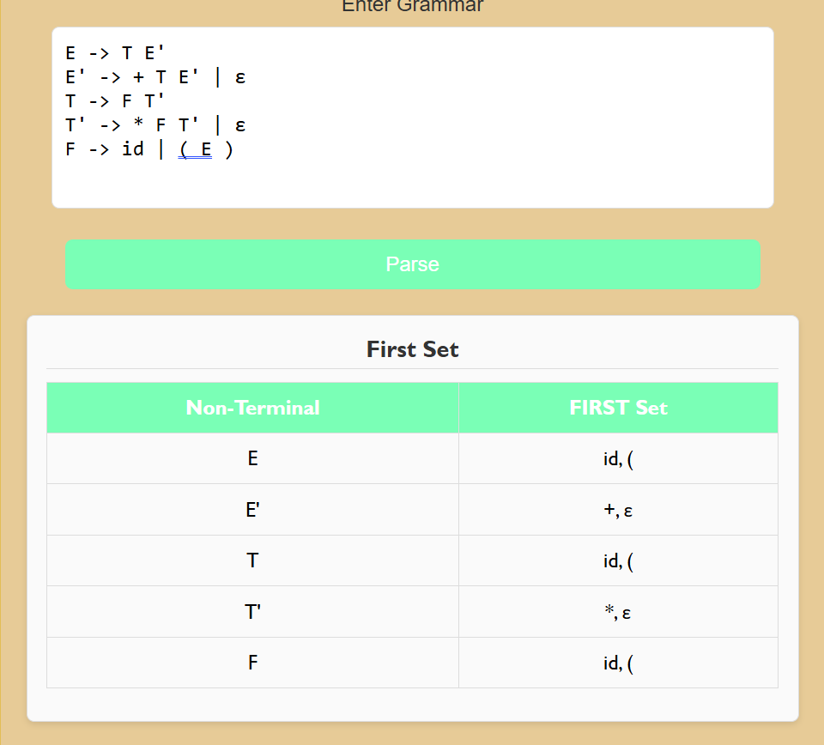

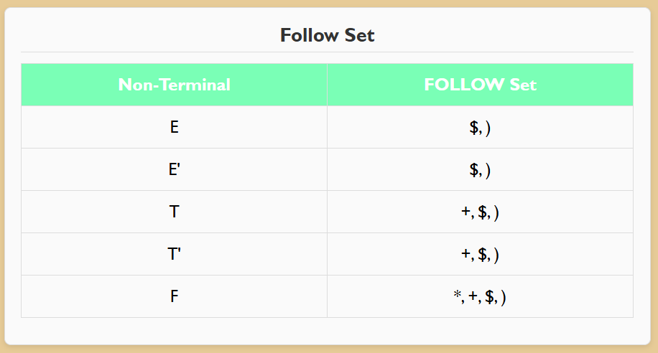

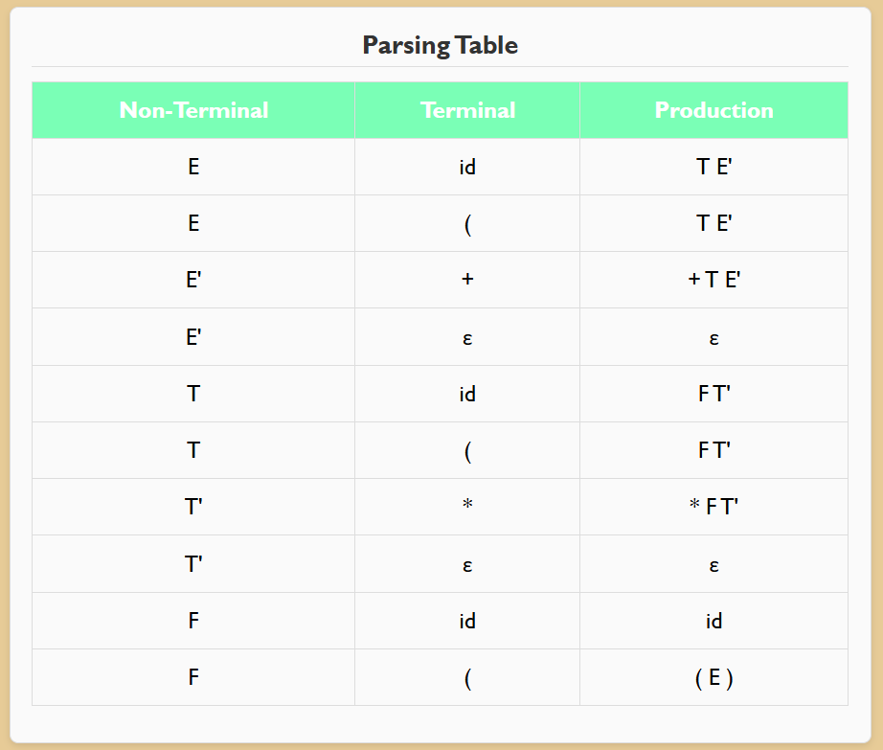

**Example-2:**

S -> a A B b

A -> c | ε

B -> d | ε

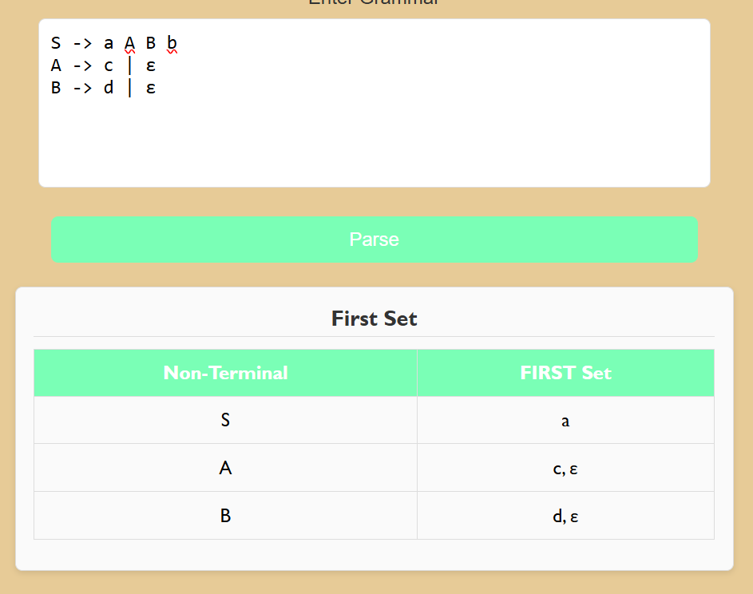

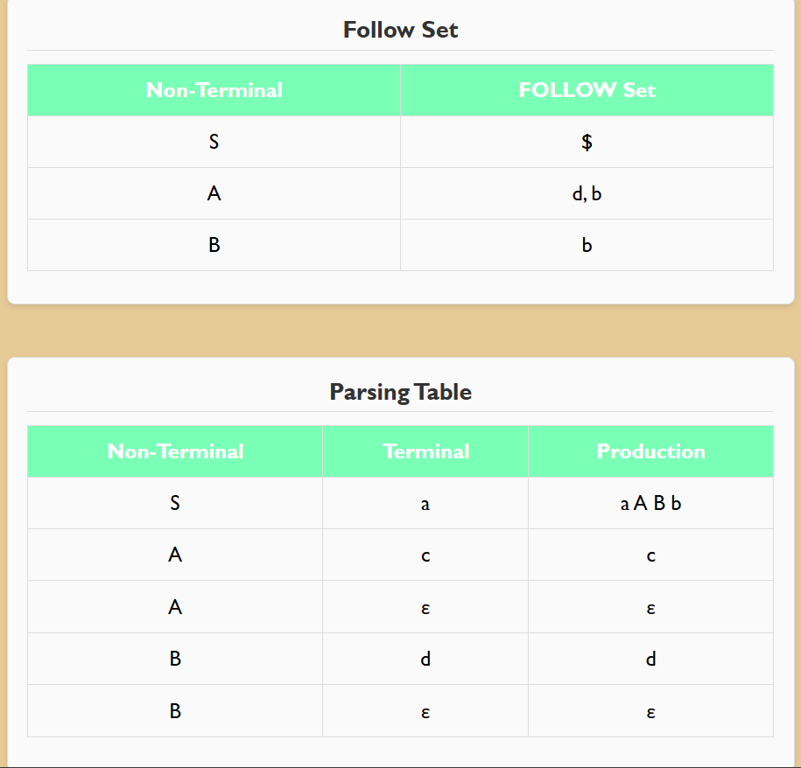

**Example-3:**

S -> A A

A -> a A | b

